Exercise 1: Display and Setup
Task 1.1: Project Setup (done)
Task 1.2: Display Student List
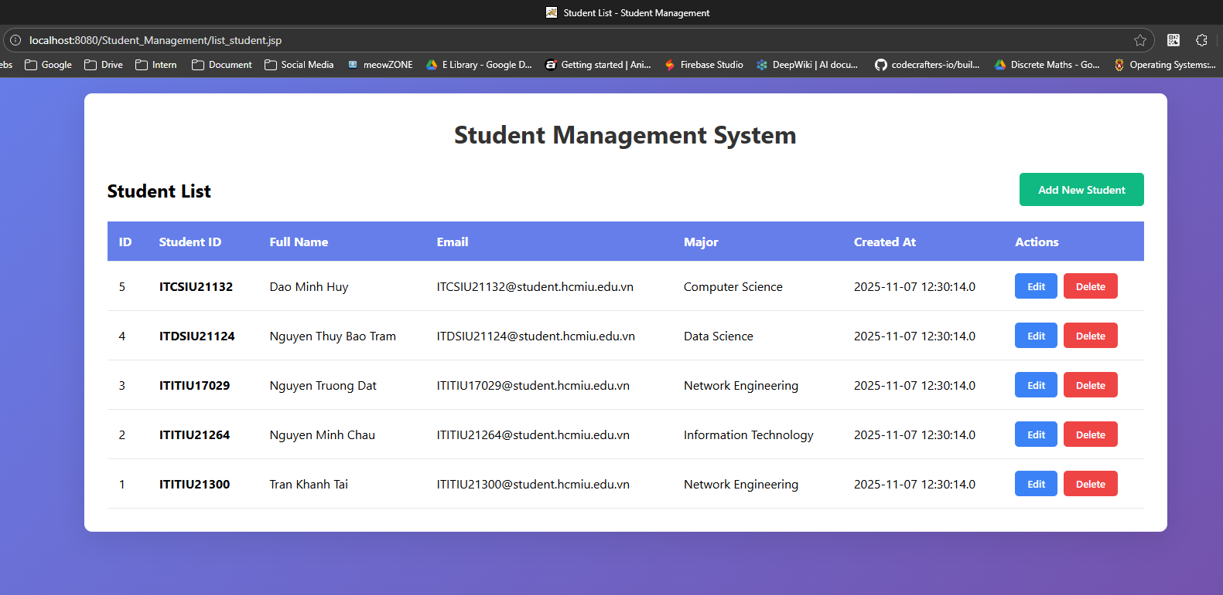
Exercise 2: Create operation
Task 2.1: Create and add Student form.
Click at Add new student button:
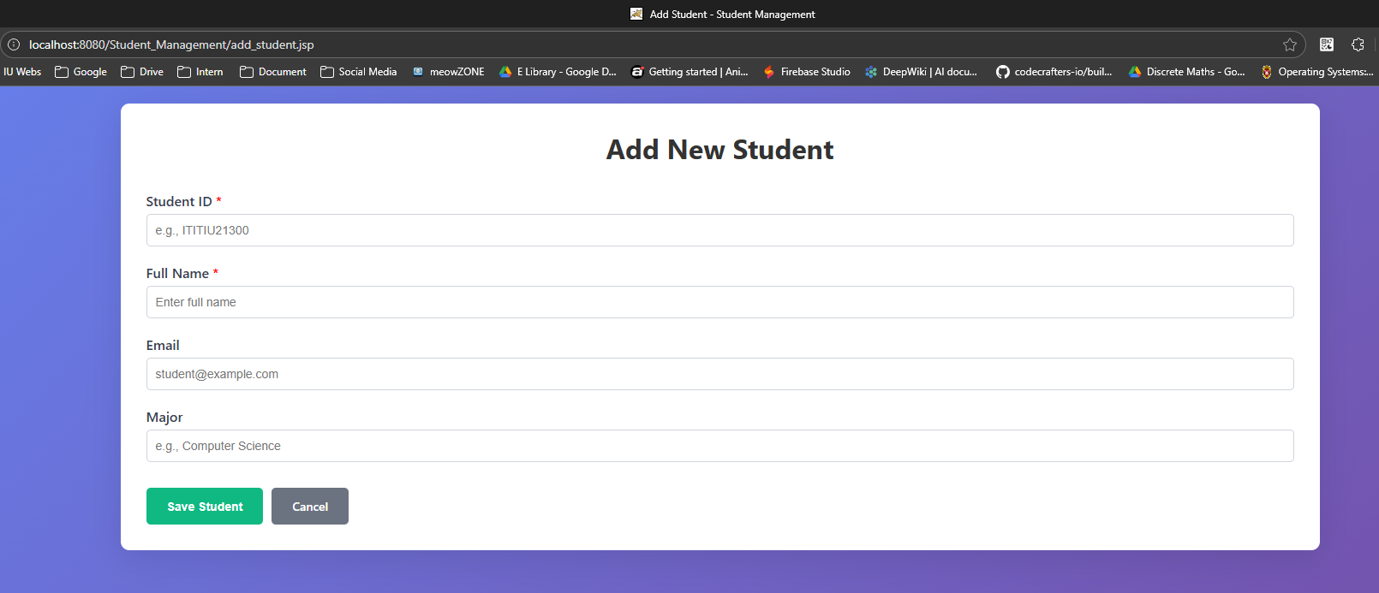

If the Student ID already exists, will appear error message
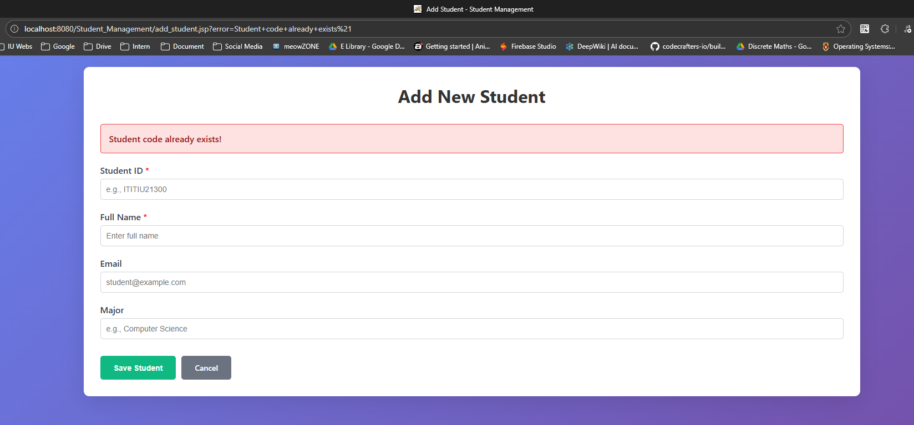
Add student:
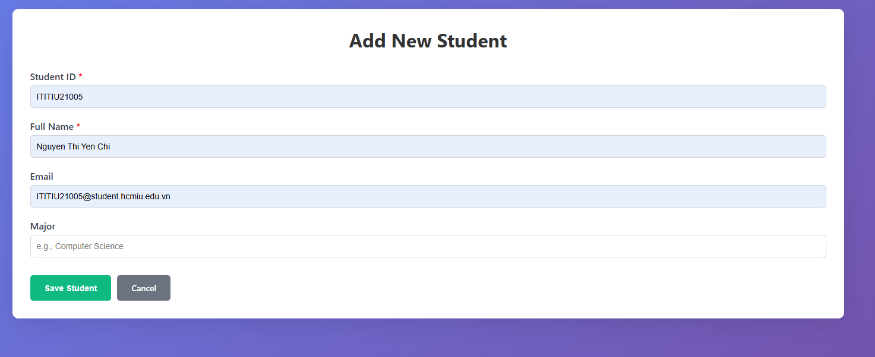

After add: 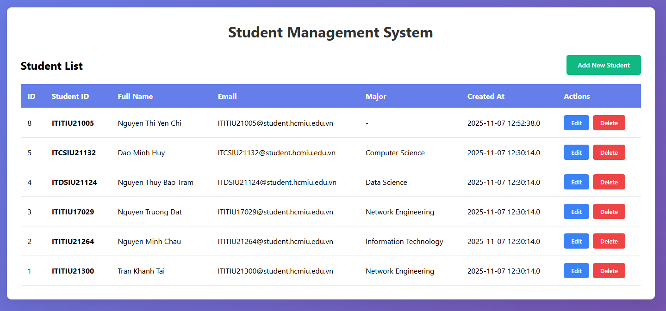

Exercise 3: Edit operation
After click on edit button: (Now we can change the information of the student, but can’t change the student ID)
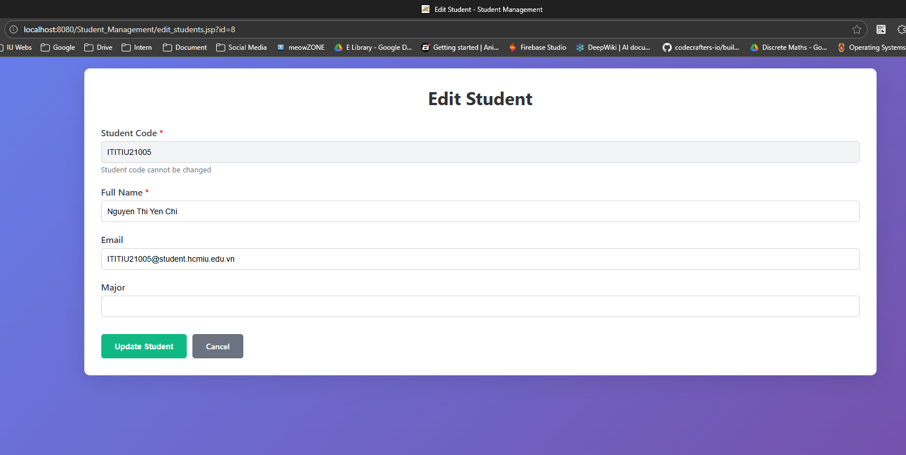
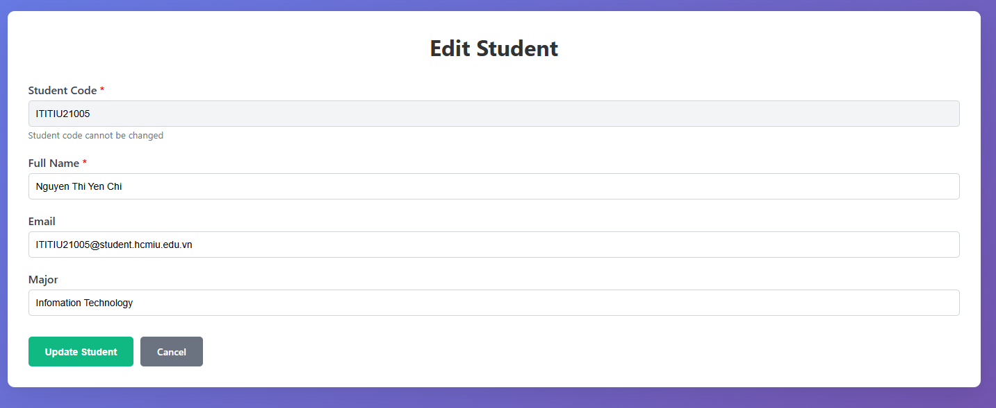
After Update:
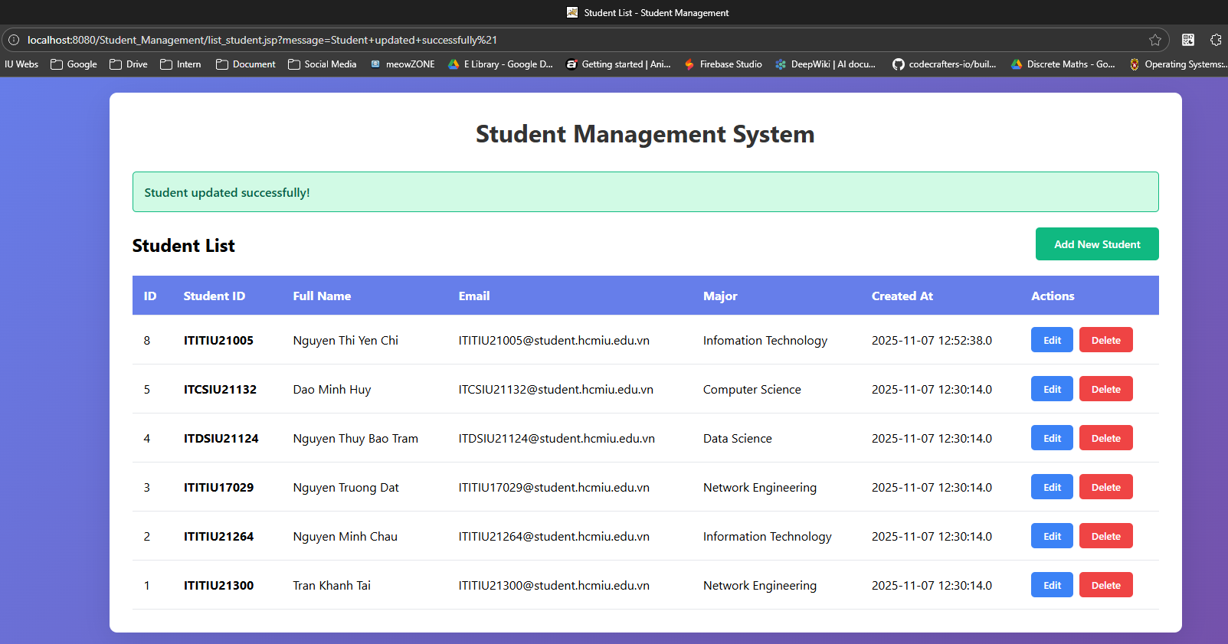

Exercise 4: Delete operation
Click delete button, it will appear an top-up to comfirmation.
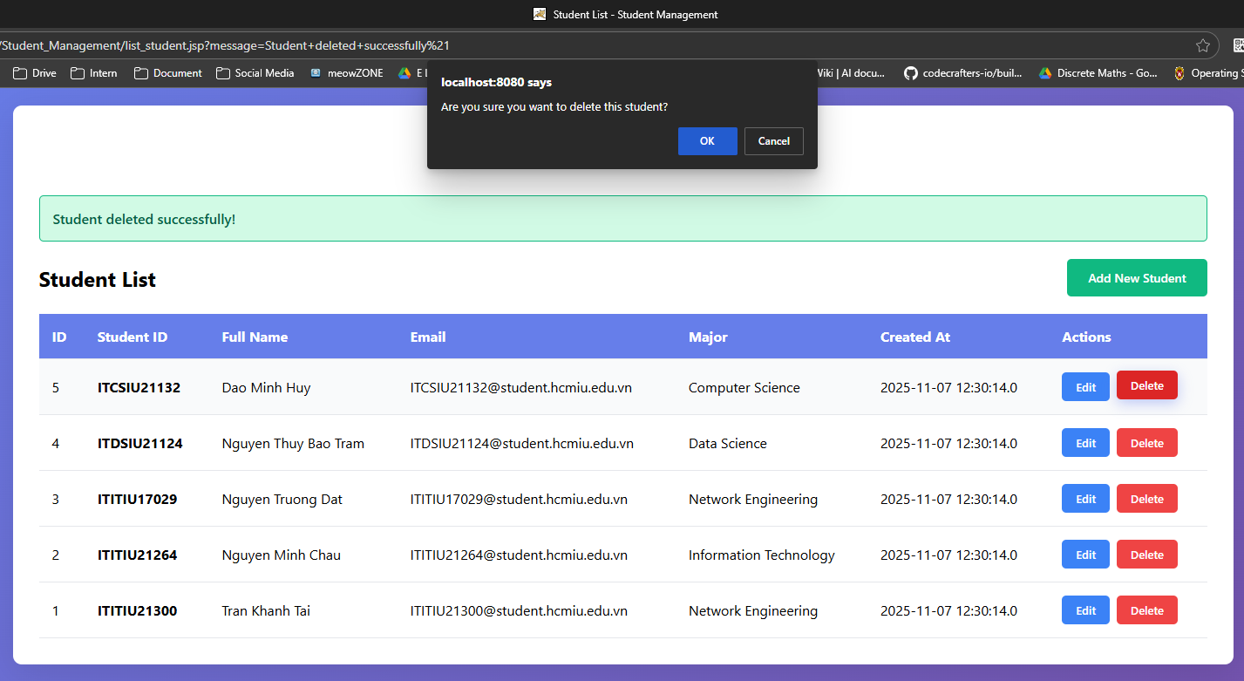
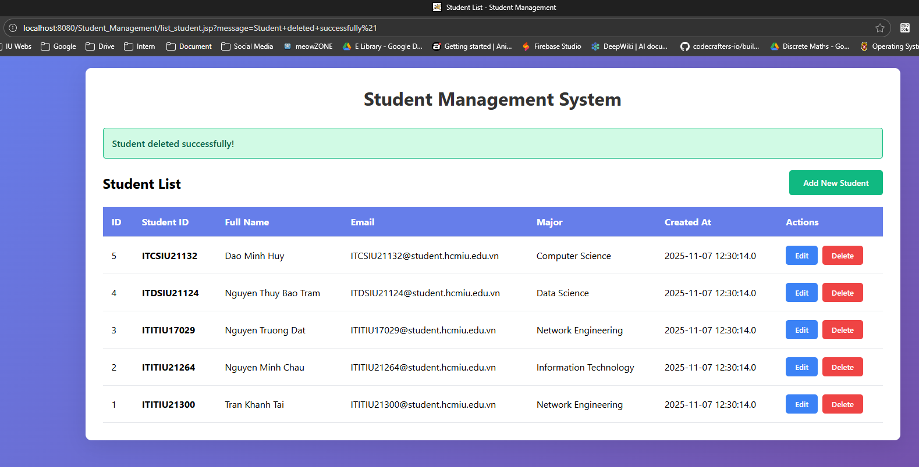
When click the OK button we can delete this.

